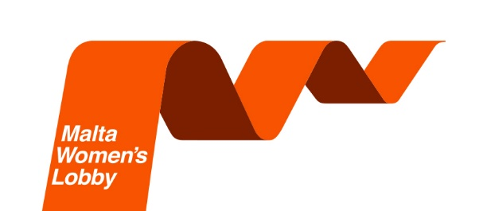
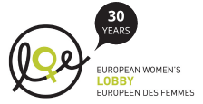

STAND UP FOR YOUR RIGHTS
Organisations Membership Application Form
JOIN THE MALTA WOMEN’S LOBBY

Name of the Organisation* ____________________________________________

Number of affiliated members: Women______________ Men________________

Address __________________________________________________________

________________________________________Post Code ________________

Contact Person____________________________________________________

Contact No: Mob: ______________________ Tel: ____________________

Email: ________________________________ Website: _____________________

Date _____________________ Signature __________________________

*One of the aims of the Organisation must be a commitment to gender equality

- Annual Fee valid from 1st January to 31st December: €80.00

- Bank transfer: BOV Account no: MT98VALL220130000000 40019741433

Commitment to comply with the General Data Protection Regulation (the GDPR), Act XX of 2018 of the Laws of Malta will ensure that any information provided will be stored for internal use and communication purposes only.

